PRACTICAL NO 7: Configure IOS Intrusion Prevention System (IPS) Using the CLI
The Cisco IOS IPS acts as an in-line intrusion prevention sensor, watching packets and sessions as they flow through the router and scanning each packet to match any of the Cisco IOS IPS signatures. When it detects suspicious activity, it responds before network security can be compromised and logs the event through Cisco IOS syslog messages or Security Device Event Exchange (SDEE). The network administrator can configure Cisco IOS IPS to choose the appropriate response to various threats. The Signature Event Action Processor (SEAP) can dynamically control actions that are to be taken by a signature event on the basis of parameters such as fidelity, severity, or target value rating. These parameters have default values but can also be configured through CLI. When packets in a session match a signature, Cisco IOS IPS can take any of the following actions, as appropriate:

- Send an alarm to a syslog server or a centralized management interface
- Drop the packet
- Reset the connection
- Deny traffic from the source IP address of the attacker for a specified amount of time
- Deny traffic on the connection for which the signature was seen for a specified amount of time

Signatures:
A signature is a set of rules that an IDS and an IPS use to detect typical intrusive activity, such as DoS attacks. We can easily install signatures using IDS and IPS management software such as Cisco IDM.
A malicious packet flow has a specific type of activity and signature, and an IDS or IPS sensor examines the data flow using many different signatures. When an IDS or IPS sensor matches a signature with a data flow, the sensor takes action, such as logging the event or sending an alarm to IDS or IPS management software, such as the Cisco SDM

We define some of the commands which will be used while configuring the Router for IPS

Commands | Function | Example
ip ips signature- category | Enters IPS category configuration mode. | Router(config)# ip ips signature-category
Category | Specifies that all categories (and all signatures) are retired in the following step and enters IPS category action configuration mode  Specifies the basic category (and a set of signatures) that are to be “unretired” in the  following step. | Router(config-ips-category)# category all  Example:  Router(config-ips-category)# category ios_ips basic
retired {true | false} | Specifies that the device should retire all categories (and all signatures).  true --Retires all signatures within a given category. false --“Unretires” all signatures within a given category. | Router(config-ips-category-action)# retired true
mkdir flash:/ips5 | Create a directory for which Cisco IOS IPS saves signature information. | Example:  Device# mkdir flash:/ips5
ip ips name ips- name |  | Example:  Device(config)# ip ips name myips
ip ips ips- name {in | out} | Applies an IPS rule at an interface and automatically loads the signatures and builds the signature engines. | Example:  Device(config-if)# ip ips MYIPS in

We us the following topology for the present case

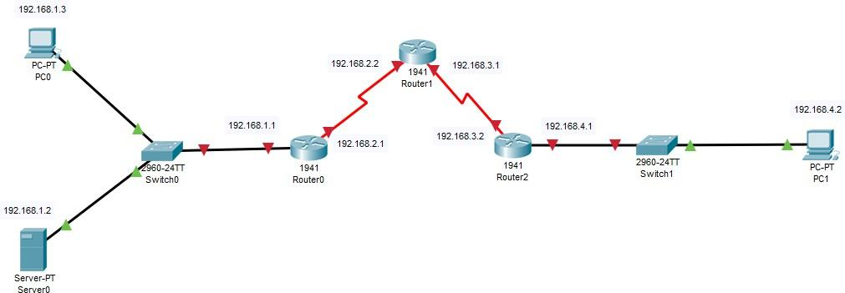

Configuring PC0
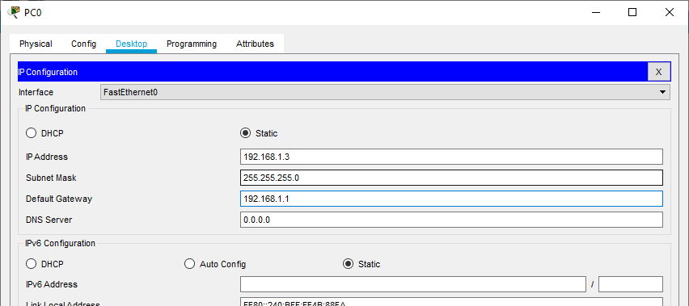

Configuring PC1
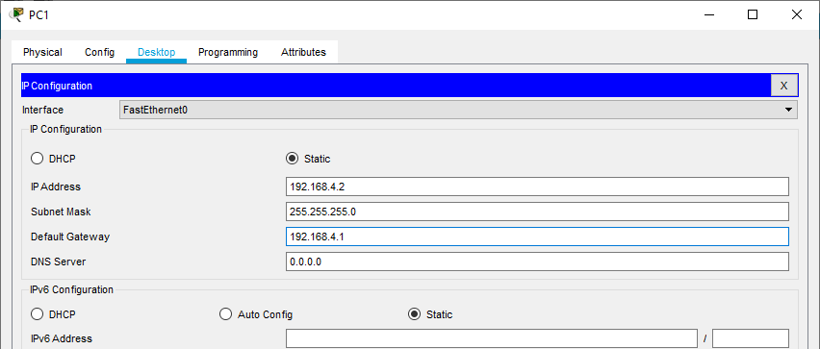

Configuring SERVER0
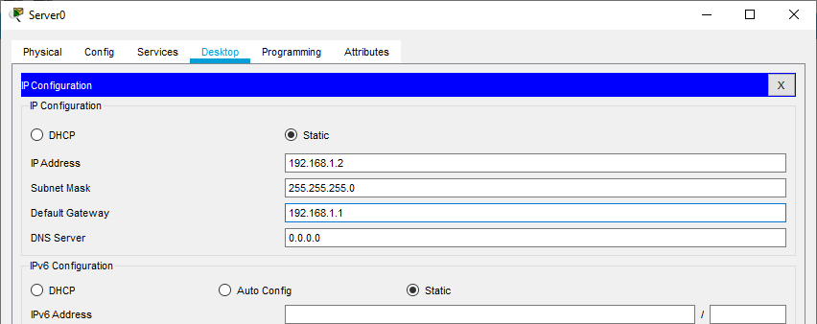

Serial Interface must be added in each Router before configuring it

Configuring Router0
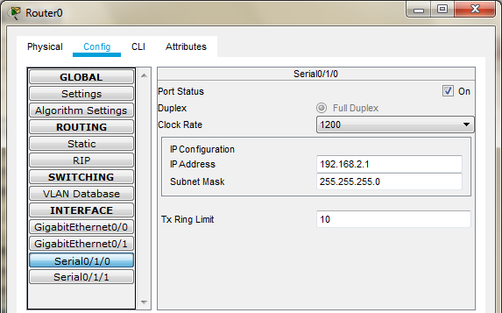

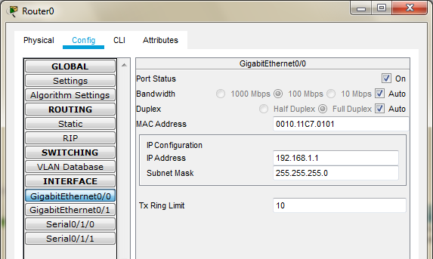

Configuring Router1
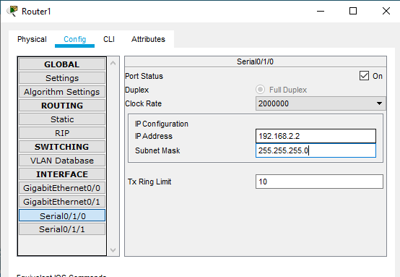
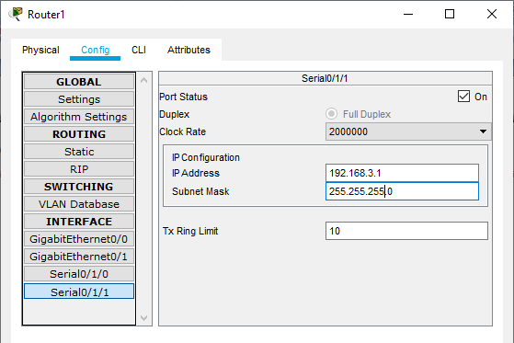

Configuring Router2
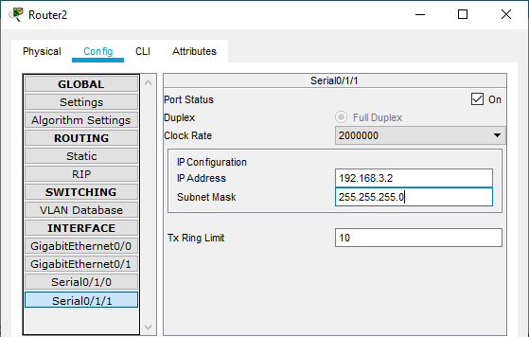
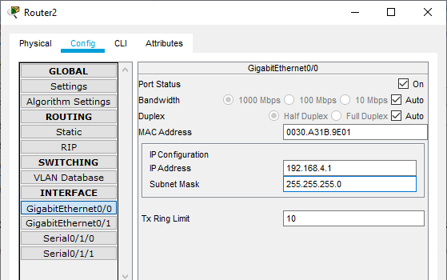

We need to set the Routing table in all the Routers so that each node could send and receive packets from others (RIP is set in all the Routers as follows)
Router0
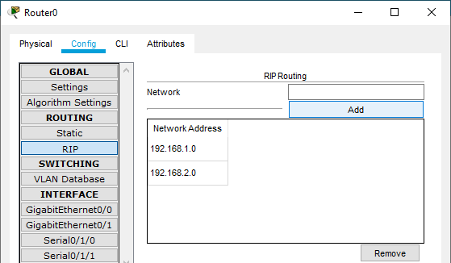

Router1
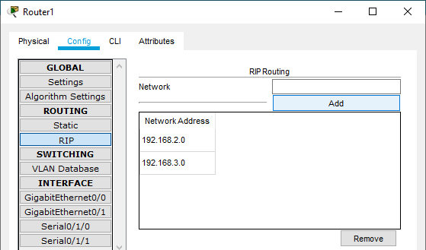

Router2
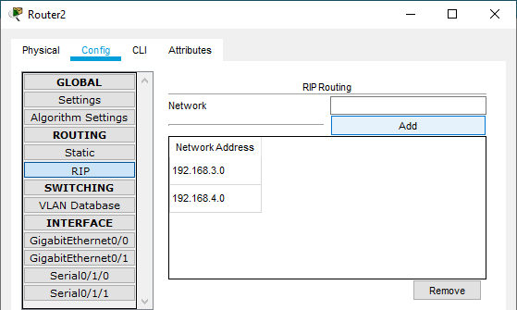

Now we can check the connectivity by sending ping commands from any node to any other node
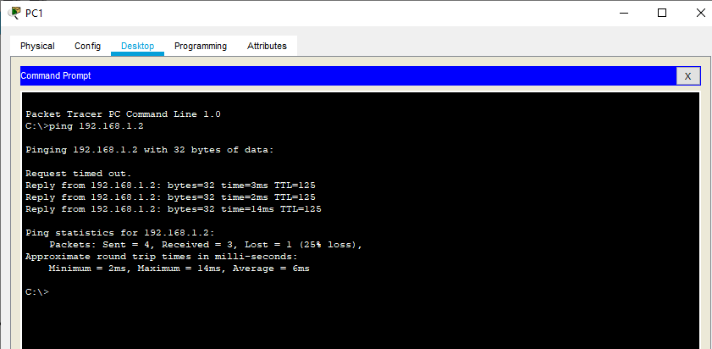

So we conclude that the connectivity has been established

PART1: Enable the IOS IPS (on Router1)

Type the following command in the CLI mode of Router1

Router#show version

We will get a message informing whether the security Package is enabled or not
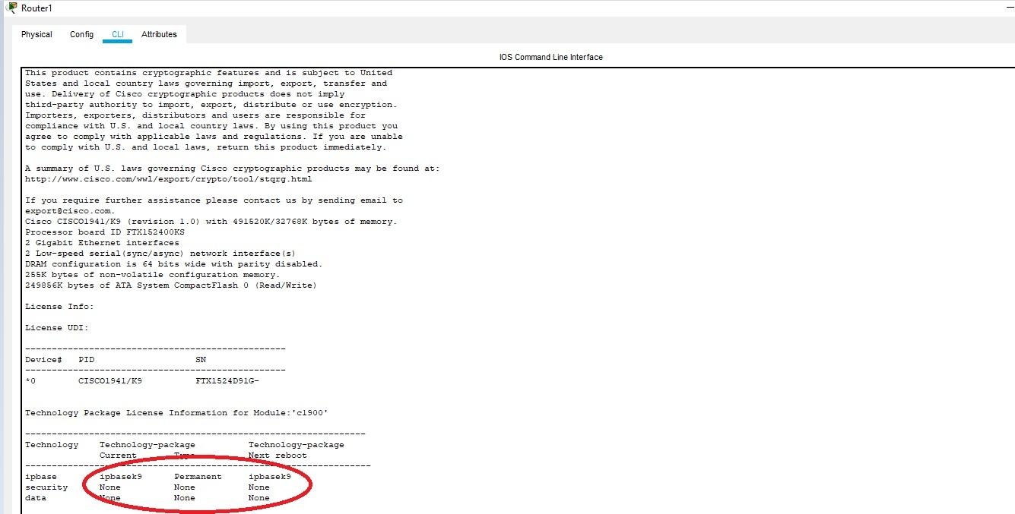

As seen above the security package is not enabled, to enable the security feature, type the following command in Router1
Router(config)#license boot module c1900 technology-package securityk9
Router(config)#exit Router# Router#reload

Router>enable Router# Router#show version

We will get a message informing whether the security package is enabled or not

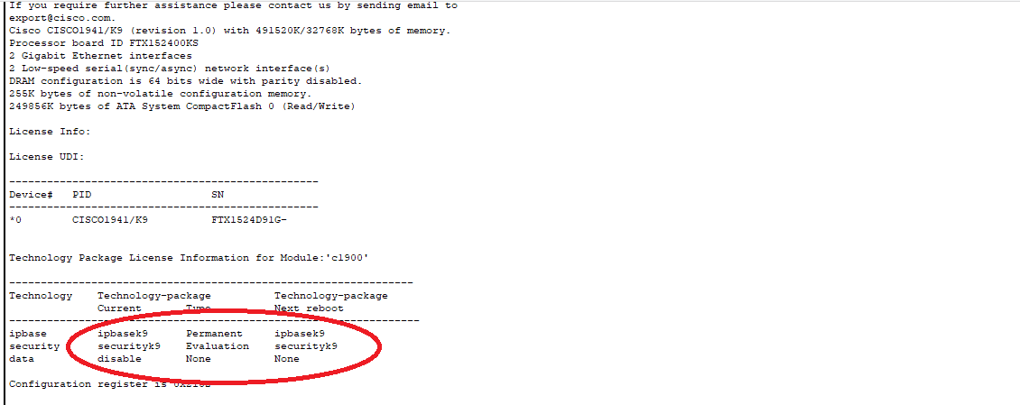

As seen above now the security package has been enabled Now type the following commands in the CLI mode of Router1

Router# Router#
Router#clock set 11:47:56 MARCH 3 2020

Router#mkdir smile Router#configure terminal
Router(config)#ip ips config location flash:smile Router(config)#ip ips name iosips Router(config)#ip ips notify log Router(config)#ip ips signature-category Router(config-ips-category)#category all Router(config-ips-category-action)#retired true Router(config-ips-category-action)#exit

Router(config-ips-category)#category ios_ips basic Router(config-ips-category-action)#retired false Router(config-ips-category-action)#exit Router(config-ips-category)#exit

Router(config)#interface Serial0/1/0 Router(config-if)#ip ips iosips out Router(config-if)#
Router(config)#

Part 2: Modify the Signature

Type the following commands in the CLI mode of Router1

Router(config)#
Router(config)#ip ips signature-definition Router(config-sigdef)#signature 2004 0 Router(config-sigdef-sig)#status Router(config-sigdef-sig-status)#retired false Router(config-sigdef-sig-status)#enabled true Router(config-sigdef-sig-status)#exit Router(config-sigdef-sig)#engine
Router(config-sigdef-sig-engine)#event-action produce-alert Router(config-sigdef-sig-engine)#event-action deny-packet-inline Router(config-sigdef-sig-engine)#exit
Router(config-sigdef-sig)#exit Router(config-sigdef)#exit Router(config)#

Now we need to verify the above IPS configuration, we do it first by pinging PC1 to SERVER and then from SERVER to PC1
PC1 to SERVER
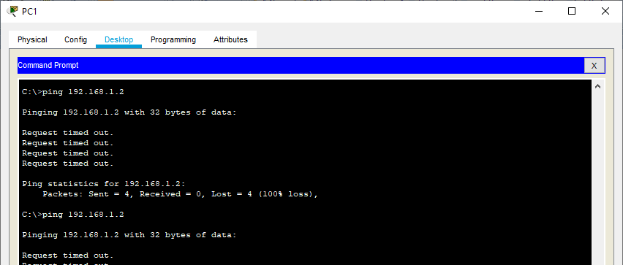

The ping FAILS

SERVER to PC1
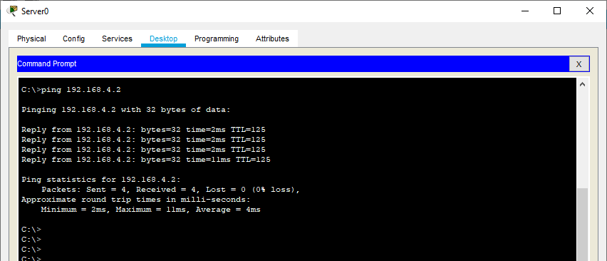

Also we can observe the Syslog service in the SERVER to check the log activities
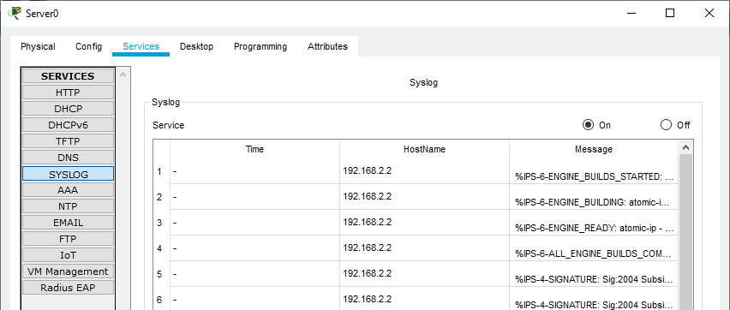

Hence we set the IPS and also verified it on Router1

